

American International University-Bangladesh (AIUB)  
**Department of Computer Science  
Faculty of Science &Technology (FST)  
Summer 18_19**

**University Portal System**

A software Engineering Sec: C project submitted

By

**ANNA, MD. AOLAD HOSSAIN (17-33513-1)**

**ISLAM, MD. ANIK (17-33459-1)**

**ISLAM, URMI TASMIM (17-33569-1) SEC-A**

The project will be Evaluated for the following Course Outcomes

|  |  |
| --- | --- |
| CO3: Choose appropriate software engineering model in a software development environment | Total Marks |
|  |
| Content Knowledge [5Marks] |  |
| Argumentation [5Marks] |  |
| Evidence of Argumentation [5Marks] |  |
| Completeness, Spelling, grammar and Organization of the Answer [5Marks] |  |
|  | |
| CO4: Explain the roles and their responsibilities in the software project management activities | Total Marks |
|  |
| Project Background Analysis [5Marks] |  |
| Project Role identification [5Marks] |  |
| Responsibility Description [5Marks] |  |
| Completeness, Spelling, grammar and Organization of the Answer [5Marks] |  |

Corporate Personnel Name:

Company:

Designation:

Contact Details:

Sign:

# PROBLEM DOMAIN

## Background to the Problem

Different educational institutions are seen to have their own portal services to manage their academic work with the students. These applications are mostly seen in the private universities in Bangladesh. Now, the project team is planning to apply the same thing and conception in the schools and colleges and see whether it satisfies the need of the students and the teachers. The System needs to be designed in such a way that it may ensure the communications and necessary class works among them. Also, the users would be able to do their academic work at ease. Often it is seen that the students miss the class due to some circumstances and the teachers sometimes fail to communicate with the students under them if there is no class representative in the class. So, the academic work gets hampered. There should be a system where the assigned people can access and get benefitted with their academic work. So, if such system is provided in a class of not more than 50 students and the teachers who are assigned for different subjects, then both the students and the teachers can get up to date with all the works regarding the subjective studies and any student won’t lag behind.

## Solution to the Problem

Nowadays, the people are more affectionate towards technology. Almost everything is based on technology. The purpose of study should not be neglected if technology is at the user’s hand. So, a web application may be developed to full fill the need of the students and the teachers of a college and see whether it makes a useful impact or not. The webpage will enable the teachers to upload notes and important notices to the students. The students may not be lagged behind in case of unwanted absence. Some more features can be added to benefit of the students and teachers. The colleges and deal with an IT farm to make them such software to solve their need. The farms can make a software similar to the plan which is documented in this project.

The main focus of this project is to satisfy the demand of the students and teachers regarding study and communication purpose. The system may ensure various use of different features including notes uploading, online quiz, direct messaging among the teachers and the students and among the students as well. Final result uploading and auto grade calculations after necessary input. The system is planned for having to different users of two different interfaces; as the user type “teacher” and user type “student”. Also, the teachers will not have to use an excel sheet rather the system may provide the name slot of the students for attendance in the interface of the user teacher. So, the objective is to ease the job of the teachers and helping the students to cope up.

The developing farm and the college authority may look for further improvement and extensions of such system. There should be good amount of research to understand the need of the students and read their mentality of what they want to have for their academic excellence. The requirements of this sort of systems should be dynamic and according to the feedback of the user.

# SOLUTION DESCRIPTION

## System Features

System features:

The features of this web-based software application is given below:

For user type Teacher -

**1.Login to the system**

**2.Uploading the notes of the class in the system.**

**3.Sending messages to the students**

**4.Getting messages of the assigned students**

**5.Opening slots for online quizzes.**

**6.Auto evaluation for MCQ format quiz**

**7.Calculate the result and grade of the students**  **8.Show the marks of definite tests 9.Take attendance of the students**

For user type students-

**1. Login to the system.**

**2.Sending messages to the teachers and classmates.**

**3.Download note of the teachers.**

**4.Participate for online MCQ quiz.**

**5.Writing on script based descriptive quiz.**

**6.See the marks of definite exams**

**7.Participation of class task.**

## UML Diagrams

**use case diagram:**

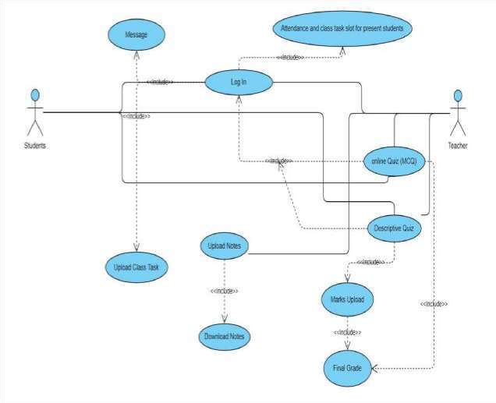

**Fig: Use case diagram of the system.**

Following is a sample use case diagram representing the University Portal System. Hence, if we look into the diagram then we will find **(Message, LOG IN, Update class Task, Attendance & class task for present students, Upload notes, Final Grade**) use case and two actors which is the student & teacher.

Activity diagram:

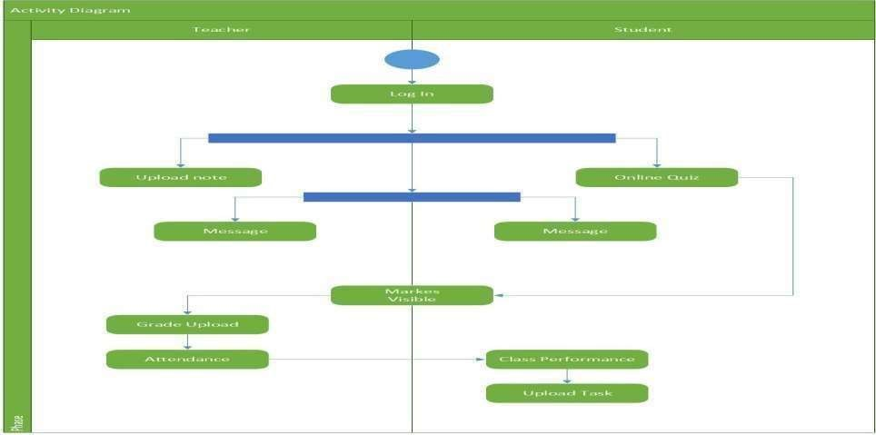

**Fig: Activity diagram with the users and work flow.**

The condition checks are performed to check if it is normal or special request. After the type of request is identified, dispatch activity is performed and that is marked as the termination of the process.

**Class diagram:**

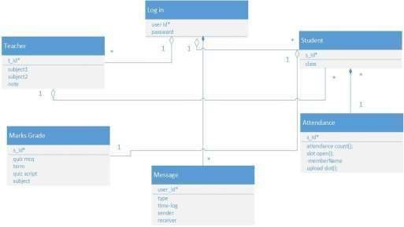

**Fig: Class diagram of the system.**

ER DIAGRAM:

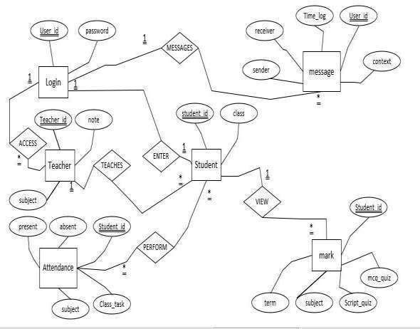

**Fig: ER diagram of the system**

# SOFTWARE DEVELOPMENT LIFE CYCLE

A software can be developed in a manner which has some procedural steps to follow or a sequence to maintain one after another. There are various development life cycles which are being applied according to the need.

**process model:**

The project work is going to be a dynamically developed system. The features enlisted can be updated and extended. Also, some more additional features may be implemented later on in this idea. In modern era, the SDLC is a major concern to the software developing farms. As, the requirements are going to be changed in further improvement and the features are required to be well defined and constructed further, the system should follow Agile software development method. The main concern of the Agile process is the customer satisfaction. So, considering from the client side, it is a must for the business purpose.

Agile is only the domain of the project life cycle to be implemented. There are various Agile development methods which are available in the software industry.

They are: Scrum, XP (Extreme programming)

DSDM (Dynamic Systems Development Method)

FDD (Feature Driven Development)

Crystal and Lean development and many more. Among this, the project work supports the DSDM Agile process to be applied in the work. The DSDM process follows some rules and regulation in the sense of application. The protocols aren’t strict but well enough to ease the development and understandable for the developers along with the clients. Software Development Life Cycle defines the steps to fellow while the developing process is ongoing. Maintenance is also considered to be the part of the development life cycle. The DSDM PROCESS follows the activities described below in the chart:

In addition, the reason behind applying DSDM is:

1. The process always aims to address the current needs of the business. The main issue is always staying in the business through iterative implementations and customer satisfaction.

2.The functional requirements can vary anytime during the development process.

1. Flexibility and prototyping are one of the key concerns in this process.
2. The current step of iteration needs to be defined enough to move towards the next step. 5. Time is a valuable issue in DSDM process. While the traditional methods the project is delivered within 18-24 months, the DSDM method needs 4-6 months for delivery. Faster than the traditional ones. 80:20 rule says that 80% of the project is finished within 20% of the time.

6. Average project team is not more than 5-6 members. So, the project team may not be large and requires small group of employees to design and construct the system. 7. Studies show that the completed projects have been rated better than the traditional methods of development. ***source: British Airways IM department, Newcastle***

8. Workshops are arranged time to time in order to give methodological views to the developers and the observers as well. Clients can also participate in such workshops regarding the project as the clients are also thought to be participants in Agile development and DSDM is indifferent to that.

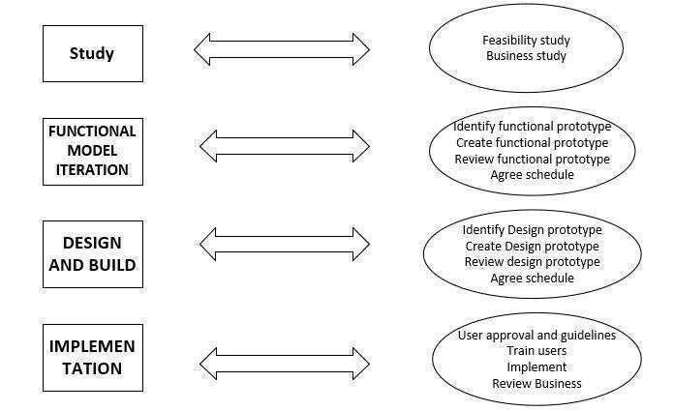

**Fig: various study and steps of process in DSDM Agile method.**

hence the project work is going to follow the DSDM Agile method in development.

## Project Roll Identification and Responsibilities

The project manager has various responsibilities for the successful project completion and maintenance. These are:

1. Activity planning of the employees and the resource planning.
2. Ensuring customer satisfaction.
3. Cost estimation and budget calculation.
4. Risk management activities.
5. Time scheduling of the work.

6. Monitoring the progress of the work and motivating the employees.

**Time scheduling of the project task:**

The project team consists of 4 members. The time scheduling and work distribution chart is described here,

The project work is broken down into different parts. The work can be divided into specific modules to be worked at. Also, the work distribution is shown in the time chart assigning the work of the responsible employees for this project.

|  |  |  |  |  |  |  |  |  |  |  |  |  |
| --- | --- | --- | --- | --- | --- | --- | --- | --- | --- | --- | --- | --- |
| Week  Task  By person | **1** | **2** | **3** | **4** | **5** | **6** | **7** | **8** | **9** | **10** | **11** | **12** |
| A: Anna |  |  |  |  |  |  |  |  |  |  |  |  |
| B:  Anna |  |  |  |  |  |  |  |  |  |  |  |  |
| C:  Urmi |  |  |  |  |  |  |  |  |  |  |  |  |
| D:  Urmi |  |  |  |  |  |  |  |  |  |  |  |  |
| E:  Anna |  |  |  |  |  |  |  |  |  |  |  |  |
| F:  Anna |  |  |  |  |  |  |  |  |  |  |  |  |
| G:  Anik |  |  |  |  |  |  |  |  |  |  |  |  |
| H:  Anik |  |  |  |  |  |  |  |  |  |  |  |  |
| I:  Urmi |  |  |  |  |  |  |  |  |  |  |  |  |

# Here

# A: Specification and design. E: Code specific module 1 I: System testing

# B: Specify and analyze design F: Code specific module 2

# C: Front end design and construct G: Code final requirements

# D: Functions and feature listing H: Integration testing

**Cost estimation and budget calculation:**  **Cost estimation:**

The project is decided to be built rather buying, reusing or contracting. The project is actually going to be an organic project. so, the estimated cost= path probability X estimated path cost

= 0.65 X 1000000 tk

= 65,0000 tk

**rough calculation of the budget:**

TIME ESTIMATED = 12 week Human resources = 4 developers per developer salary each month is 50,000 tk so per week it should be

50000 tk/4= 12,500 tk after 12 weeks it is

12,500 X 12 = 150,000 tk so for 4 employees it is

= 150,000 X 4 = 60,0000tk

extra costings: food costing = 10,000 tk office rent = 20,000 tk for 12 weeks = 3 X 20,000 tk = 60,000 tk electricity bill = 3 X 1000 tk = 3000 tk

so, in total = (60,0000 tk + 10,000 tk + 60,000 tk + 3000 tk)

= 67,3000 tk profit demanded = 150000 tk so total charge = profit + cost = 15,0000 tk + 67,3000 tk =**82,3000 tk**

these are the tasks that the project manager has to ensure for the completion of the work and delivering the product to the customer. The risk management and time scheduling issues are up to the project manager.

The managerhas the right to take any decision regarding the success of the project.